# **PRACTICE REPORT**

# **WEB PROGRAMMING LAB WORKS**

# **MODULE 3**

# **“PHP (Hypertext Preprocessor)”**



**Assembled by:**

# **ONIC AGUSTINO**

# **L200234275**

**X**

**PROGRAM STUDI TEKNIK INFORMATIKA**

**FAKULTAS KOMUNIKASI DAN INFORMATIKA**

**UNIVERSITAS MUHAMMADIYAH SURAKARTA**

**TAHUN 2024/2025**

**PRACTICE**

1. **Experiment 1 (Variable)**

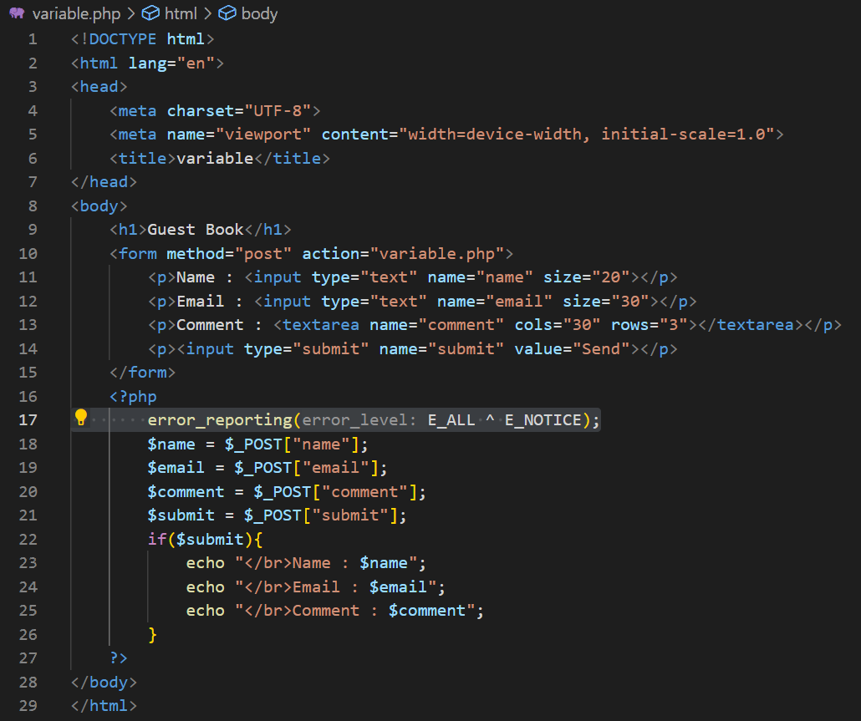

Picture 1.1 The Code.

(Explanation)

This HTML and PHP code creates a guest book form where users can enter their name, email, and comments. The form uses the POST method to send data to variable.php, but the PHP script processes it directly. The error_reporting(E_ALL ^ E_NOTICE); prevents warnings for undefined variables. If the submit button is clicked, the script retrieves and displays the inputted data.

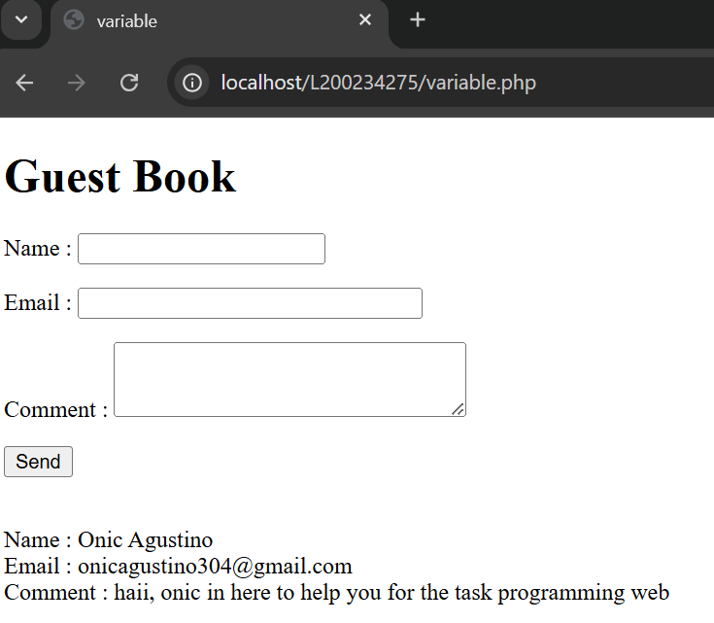

Picture 1.2 The Output.

1. **Experiment 2 (Control Structure)**

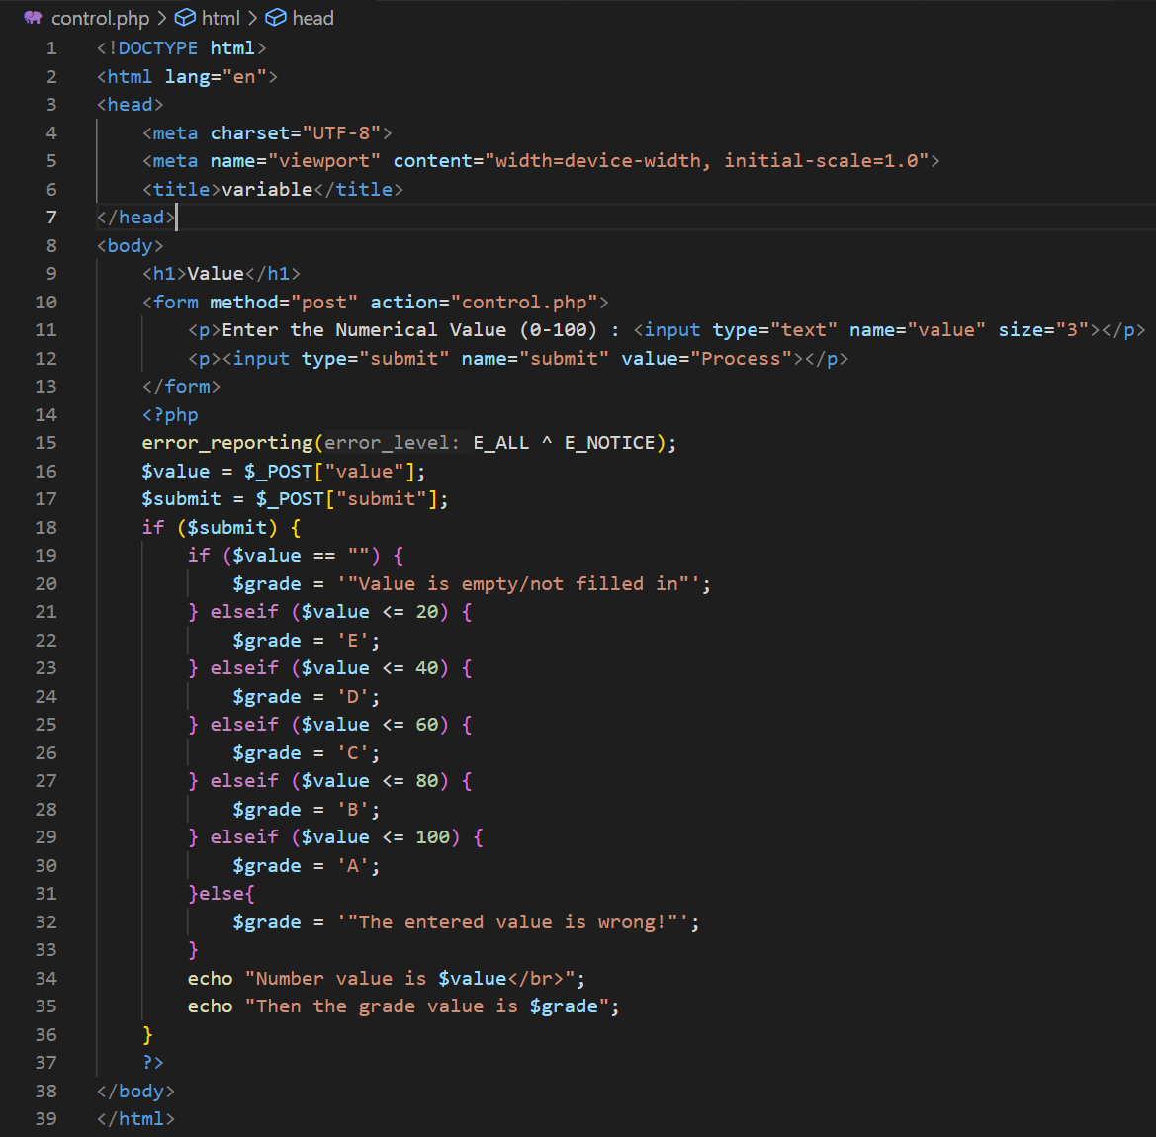

Picture 2.1 The Code.

(Explanation)

This HTML and PHP code creates a form for users to enter a numerical value (0-100). The PHP script processes the input and assigns a grade (`A` to `E`) based on the value range. If the input is empty, it displays `"Value is empty/not filled in"`, and if it's out of range, it shows `"The entered value is wrong!"`. The `error_reporting(E_ALL ^ E_NOTICE);` prevents warnings for undefined variables.

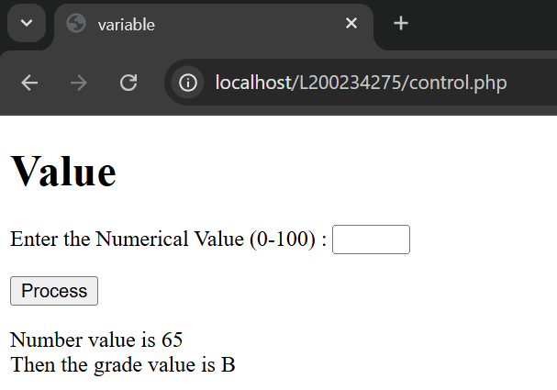

Picture 2.2 The Output.

1. **Attempt 3 (File Upload)**

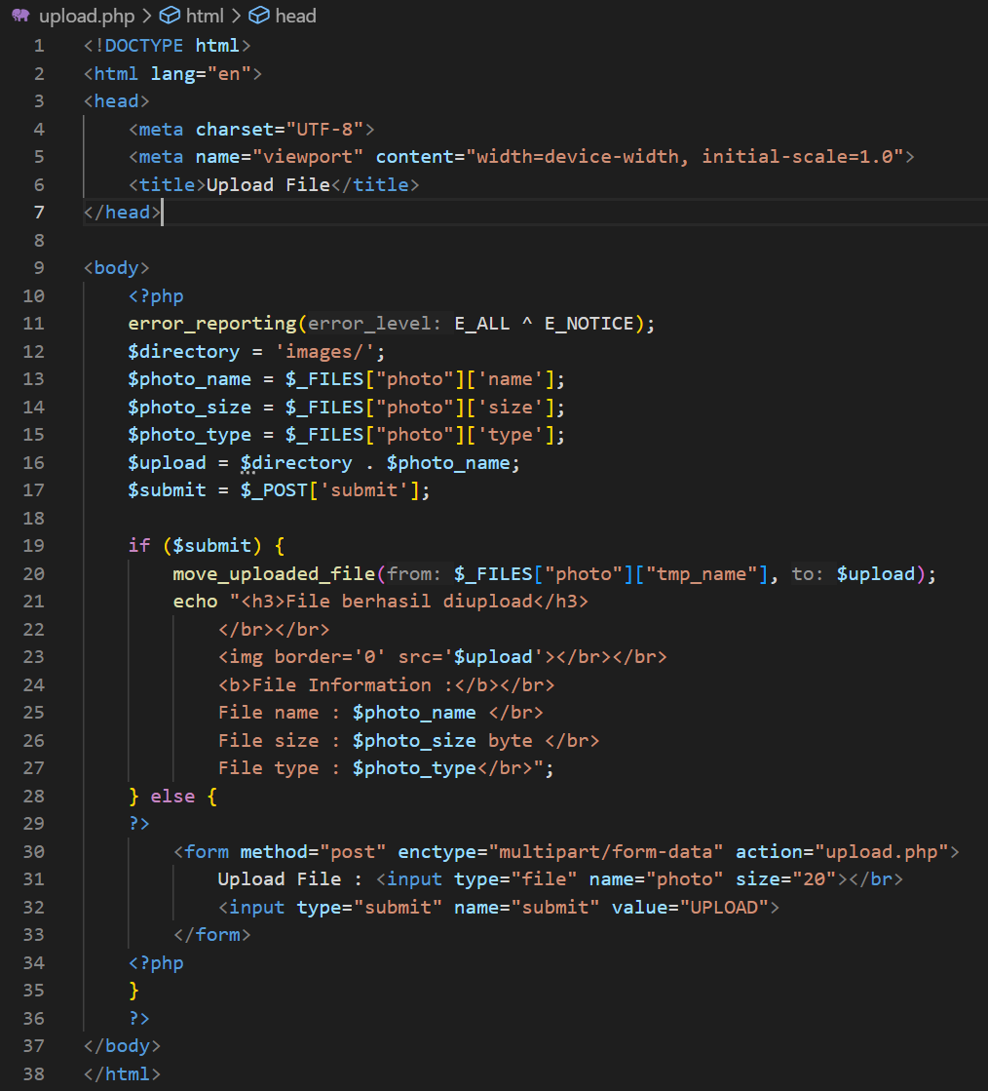

Picture 3.1 The Code

(Explanation)

This HTML and PHP code allows users to upload a file. The form uses enctype="multipart/form-data" to handle file uploads. The PHP script saves the uploaded file in the images/ directory and displays its details (name, size, and type).

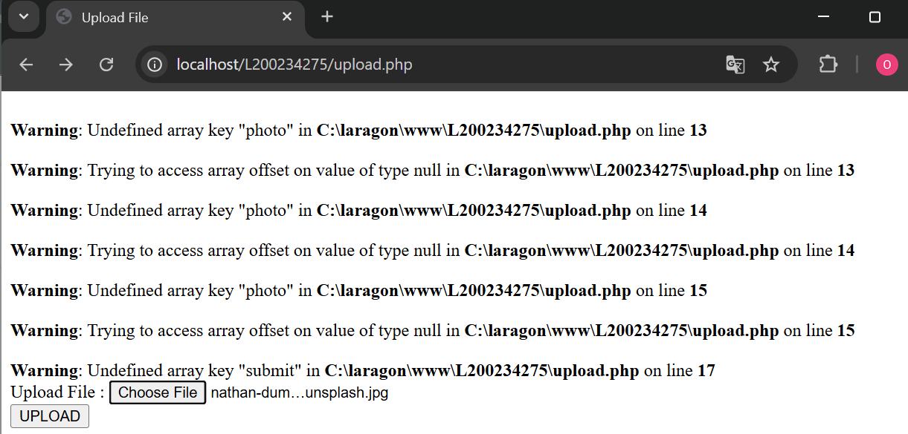

Picture 3.2 The Output before upload image to folder image.

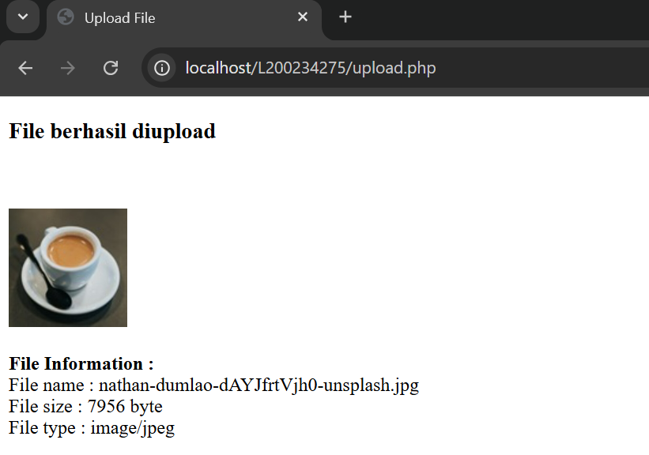

Picture 3.3 After you upload.

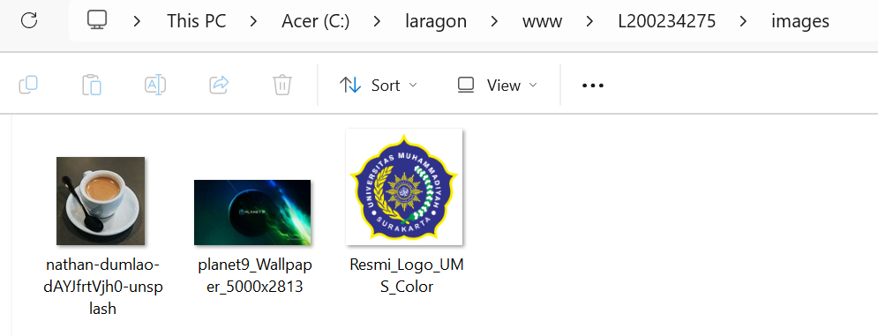

Picture 3.4 content this folder images.

1. **Experiment 4 (Date and Time Function)**

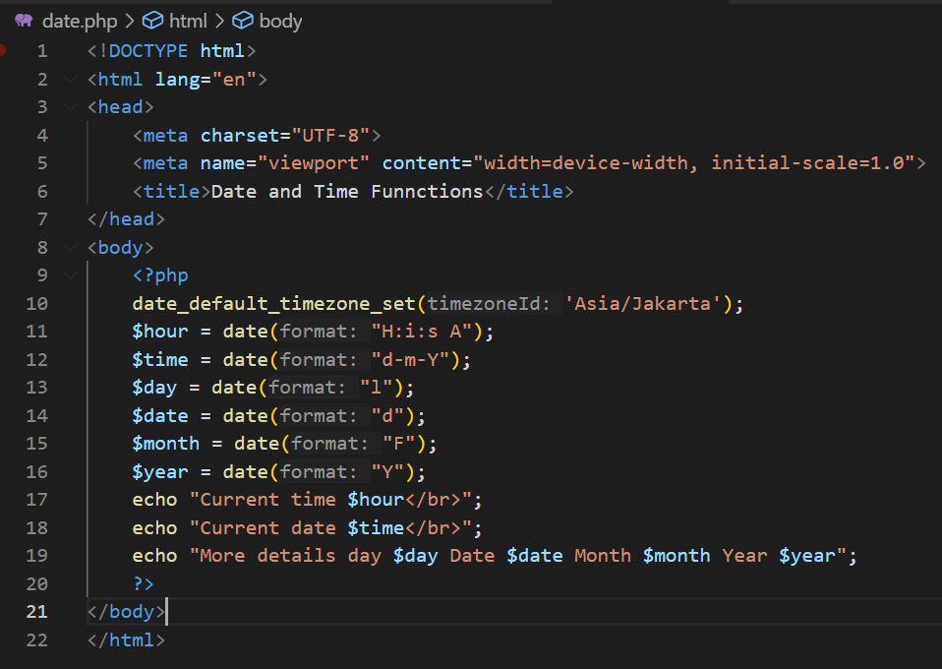

Picture 4.1 The Code.

(Explanation)

This PHP script displays the current date and time using the date() function. It sets the timezone to Asia/Jakarta with date_default_timezone_set('Asia/Jakarta');.

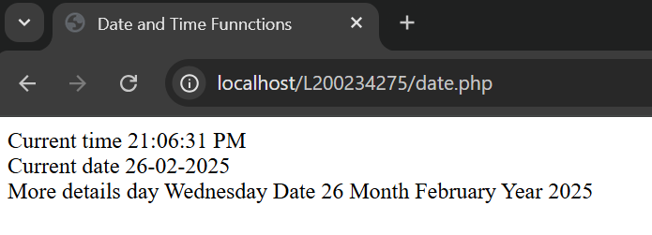

Picture 4.2 The Output.

**ASSIGNMENT**

1. **Write an PHP script to create an addition program using a variable function as shown in the image below. Then print the results screen in the browser, and attach them to the report**

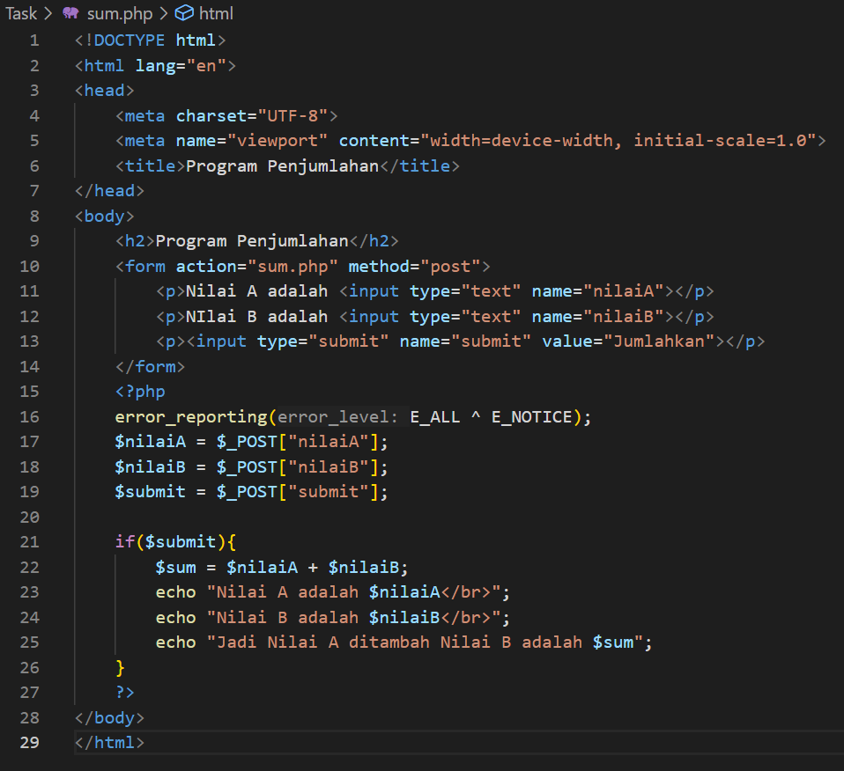

Picture Task.1.1 The code.

(Explanation)

This program takes two user inputs (`nilaiA` and `nilaiB`) and adds them together. The form submits data using the **POST** method to `sum.php`. The PHP script retrieves the values and checks if the submit button is clicked. The sum of `nilaiA` and `nilaiB` is calculated and displayed.

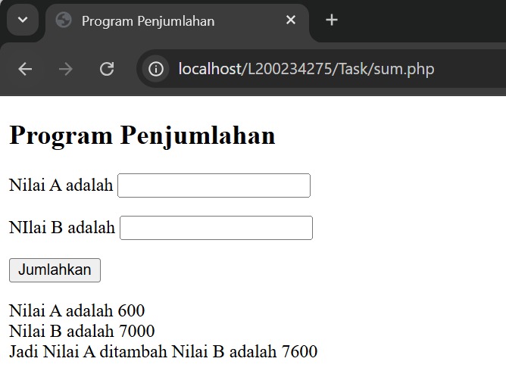

Picture Task.1.2 The Output

1. **Write a program to determine whether a number is odd or even using a PHP script**

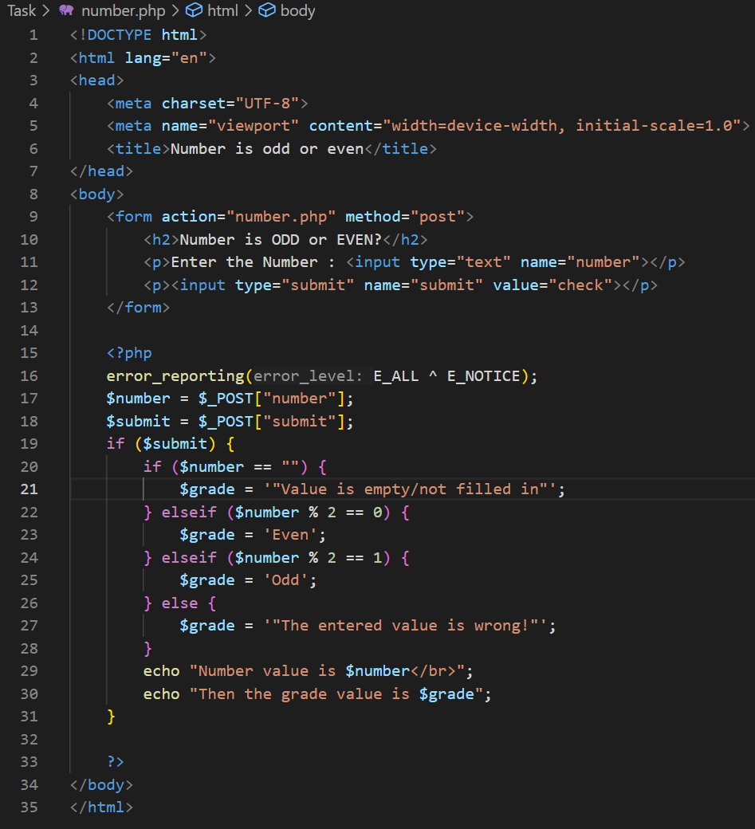

Picture Task.2.1 The Code.

(Explanation)

This program checks whether a number is odd or even based on user input. The form submits a number using the POST method to number.php. The PHP script retrieves the input and verifies if the submit button was clicked. If the input is empty, an error message is shown; otherwise, it checks if the number is **even (% 2 == 0)** or **odd (% 2 == 1)**. The result is then displayed.

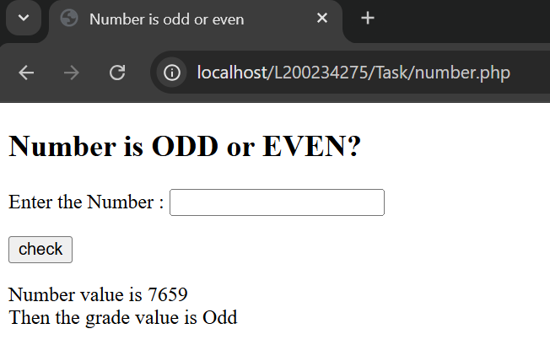

Picture Task.2.2 The Output.